**GRID Alternatives’ Energy For All Program**

**(Disadvantaged Communities – Single-family Affordable Solar Homes Program DAC-SASH)**

GRID Alternatives is a **mission driven** **non-profit** **that serves exclusively low-to-moderate income families**. GRID Alternatives is the statewide Program Manager and Installer for the Disadvantaged Communities Single-Family Affordable Solar Homes (DAC-SASH) program under the California Public Utilities Commission (CPUC).

**Homeowners qualified to receive solar through GRID Alternatives’ Energy For All Program are eligible for a no-cost solar system that can save on a family’s electric bill.**

The Energy For All program, when combined with GoSolarSF, offers incentives for solar electric systems to income-qualified homeowners living in certain areas and neighborhoods of San Francisco served by CleanPowerSF, or Hetch Hetchy Power. In addition to providing incentives, GRID’s program is uniquely structured to promote and provide energy education, workforce development and solar job training opportunities along with broad community engagement.

Households must meet the criteria below to be eligible for GRID’s services (see “Determining Eligibility”). GRID Alternatives has the sole authority to determine and confirm eligibility. **Contact GRID Alternatives** in one of the following ways:

1-866-921-4696

www.energyforallprogram.org (online form)

**Determining Eligibility**

Eligible applicants must meet ALL of the following criteria to qualify:

* Must receive electrical service from Pacific Gas & Electric (PG&E) and be a CleanPowerSF electric customer or a SFPUC Hetch Hetchy Electric customer.
* Must own and occupy a single-family home as applicant's primary residence,
* The residence address must be located in a disadvantaged community (DAC) identified by the [CalEnviroScreen 4.0 map](https://experience.arcgis.com/experience/1c21c53da8de48f1b946f3402fbae55c/page/SB-535-Disadvantaged-Communities/) (only homes in the red areas of the below map qualify)
* Total household income is at or below the maximum annual income limits (see table below).

Think you qualify? [Complete the online eligibility form](https://www.gridsolar.org/dac1) or call GRID Alternatives toll-free at (866) 921-4696 to coordinate a pre-screening phone conversation.

|  |  |
| --- | --- |
| **HOUSEHOLD SIZE** | **MAXIMUM ANNUAL INCOME**  **(2024)** |
| 1-2 | $ 40,880 |
| 3 | $ $64,550 |
| 4 | $78,000 |
| 5 | $91,450 |
| 6 | $104,900 |
| 7 | $118,350 |
| 8 | $131,800 |
| 9 | $145,250 |
| 10 | $158,700 |
| Add $10,760-$13,450 for each additional household member | |
| *To calculate total income, add income for all household member above 18 y o. for the most recent tax year using line 9 (1040 form and / or total income on other taxable income (W2, unemployment, etc.)* | |

**SAN FRANCISCO QUALIFIED AREAS**

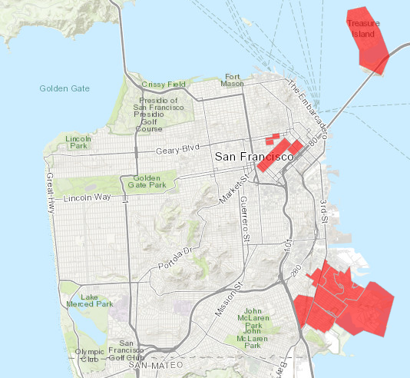

[Click here for an interactive version of this map](http://oehha.maps.arcgis.com/apps/View/index.html?appid=c3e4e4e1d115468390cf61d9db83efc4)